Practical 6

Aim :Create Product Catalog Application using ASP.NET MVC Architecture. (Controllers, Models, Views, Routing)
Project name: practical_6dotnet (Model)Source code: Product.cs
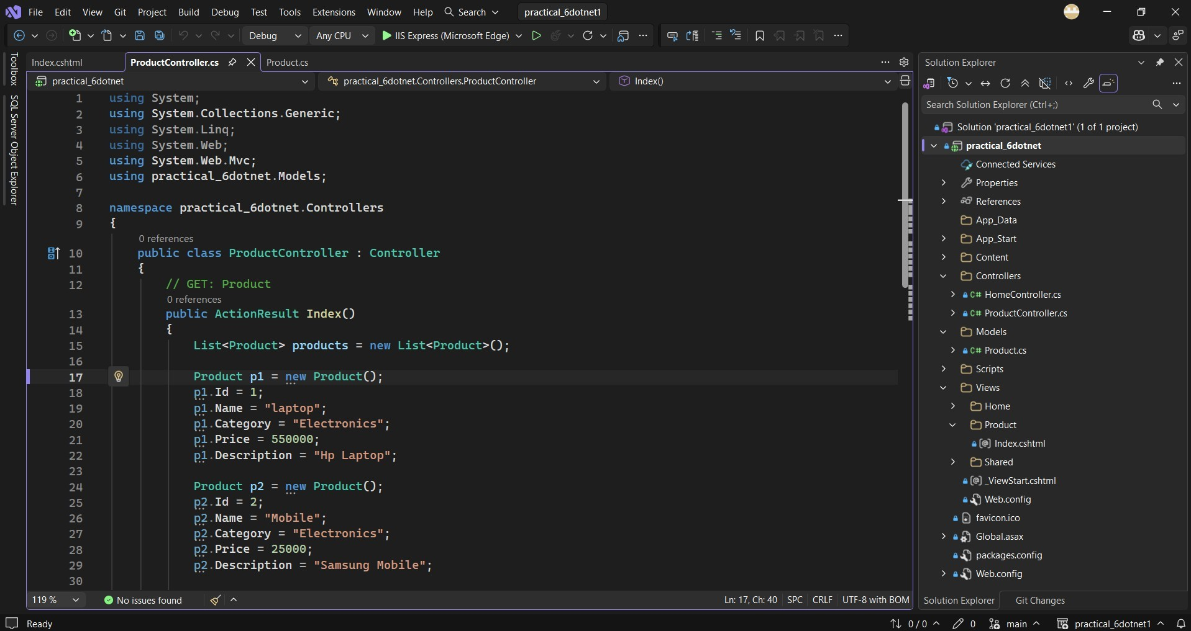

using System;
using System.Collections.Generic; using System.Įinq;
using System.Web;

namespace practical_6dotnet.Models
{
public class Product
{
public int Id { get ; set; } public string ame { get; set; }
public string Category { get; set; } public decimal Price { get; set; } public string Description { get; set; }
}
}

(Controller)Source code: ProductController.cs

using System;
using System.Collections.Generic; using System.Įinq;
using System.Web; using System.Web.Mvc;
using practical_6dotnet.Models;

namespace practical_6dotnet.Controllers
{
public class ProductController : Controller
{
// GET: Product
public ActionResult Index()
{
Įist<Product> products = new Įist<Product>(); Product p1 = new Product();

p1.Id = 1;
p1.ame = "laptop"; p1.Category = "Electronics"; p1.Price = 550000; p1.Description = "p Įaptop";

Product p2 = new Product();

p2.Id = 2;
p2.ame = "Mobile"; p2.Category = "Electronics"; p2.Price = 25000;
p2.Description = "Samsung Mobile";

Product p3 = new Product(); p3.Id = 3;
p3.ame = "Chair"; p3.Category = "Furniture"; p3.Price =7500;
p3.Description = "office chair";

products.Add(p1); products.Add(p2); products.Add(p3);
return View(products);
}
}
}

(View) source code: Index.cshtml
@model Įist<practical_6dotnet.Models.Product>

@{
Įayout = null;
}

<!DOCTYPE html>

<html>
<head>

<meta name="viewport" content="width=device-width" />
<title>index</title>
</head>
<body>
<div>
<h2>Product Catalog</h2>

<table border="1" cellpadding="8">
<thead>
<tr>
<th>Id</th>
<th>ame</th>
<th>Category</th>
<th>Price</th>
<th>Description</th>
</tr>
</thead>
<tbody>
@foreach (var product in Model)
{
<tr>
<td>@product.Id</td>
<td>@product.ame</td>
<td>@product.Category</td>
<td>@product.Price</td>
<td>@product.Description</td>
</tr>
}
</tbody>
</div>
</body>
</html>

Output:
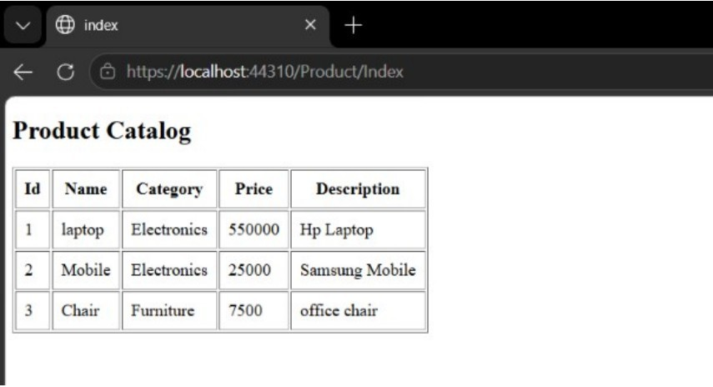

Github Link: https://github.com/ajaysakethsanka-cell/dot_net_Lab_practicals-

